Complaint Intake Form
Please note the following:
- Complaints will be addressed in accordance with the Hockey New Brunswick Safe Sport Policy Manual along with supporting policies that may apply on a case-by-case basis.
- Hockey New Brunswick cannot guarantee confidentiality. The contents of this document may be shared in an effort to resolve this complaint. The defendant will have the right to see the complaint, in order to defend the allegations.
- Complaints related to Maltreatment, will be sent to Hockey Canada Independent Third Party.
- Complaints which are criminal in nature, will be forwarded to the local police authority, and will not be investigated by Hockey New Brunswick.
- Once completed, this form can be emailed to info@hnb.ca

Please complete the following:
- Person filing complaint: ☐ Player ☐ Parent ☐ Volunteer ☐ Official ☐ Employee

First Name |  | Last Name
Minor Hockey Association | Team |  | Position with Team/Association
Telephone Number |  | Email

- Person on whose behalf the complaint is made: (if same as above, leave blank)

First Name | Last Name
Birth Date (dd/mm/yyyy)

- Name of person(s) who the complaint is being filed against:

First Name | Last Name
Minor Hockey Association | Team | Title/Role
First Name | Last Name
Minor Hockey Association | Team | Title/Role

- When did the incident(s) occur? (dd/mm/yyyy): ___________________________________

- Particulars: Please provide a summary of the incident(s) you are complaining about. Your summary must answer the following questions. If additional space is required, you can attach a document.

- Date that the incident(s) happened
- Where did the incident happen?
- Who was involved?
- What happened?
- How do the incidents relate to the ground(s) you selected?
- Remedy/Resolutions you are seeking

- Witnesses
Did anyone else witness the incident? If so, please provide their name and contact information.
Witness # 1
First Name | Last Name
Telephone Number | Email
Relationship with complainant

Witness # 2

First Name | Last Name
Telephone Number | Email
Relationship with complainant

Witness # 3

First Name | Last Name
Telephone Number | Email
Relationship with complainant

- Declaration

I hereby declare that the information provided in this Complaint Form is true and correct to the best of my knowledge. I understand that if I have knowingly provided false information, I may be subject to disciplinary action by Hockey New Brunswick.

Name:

Date:

Signature:

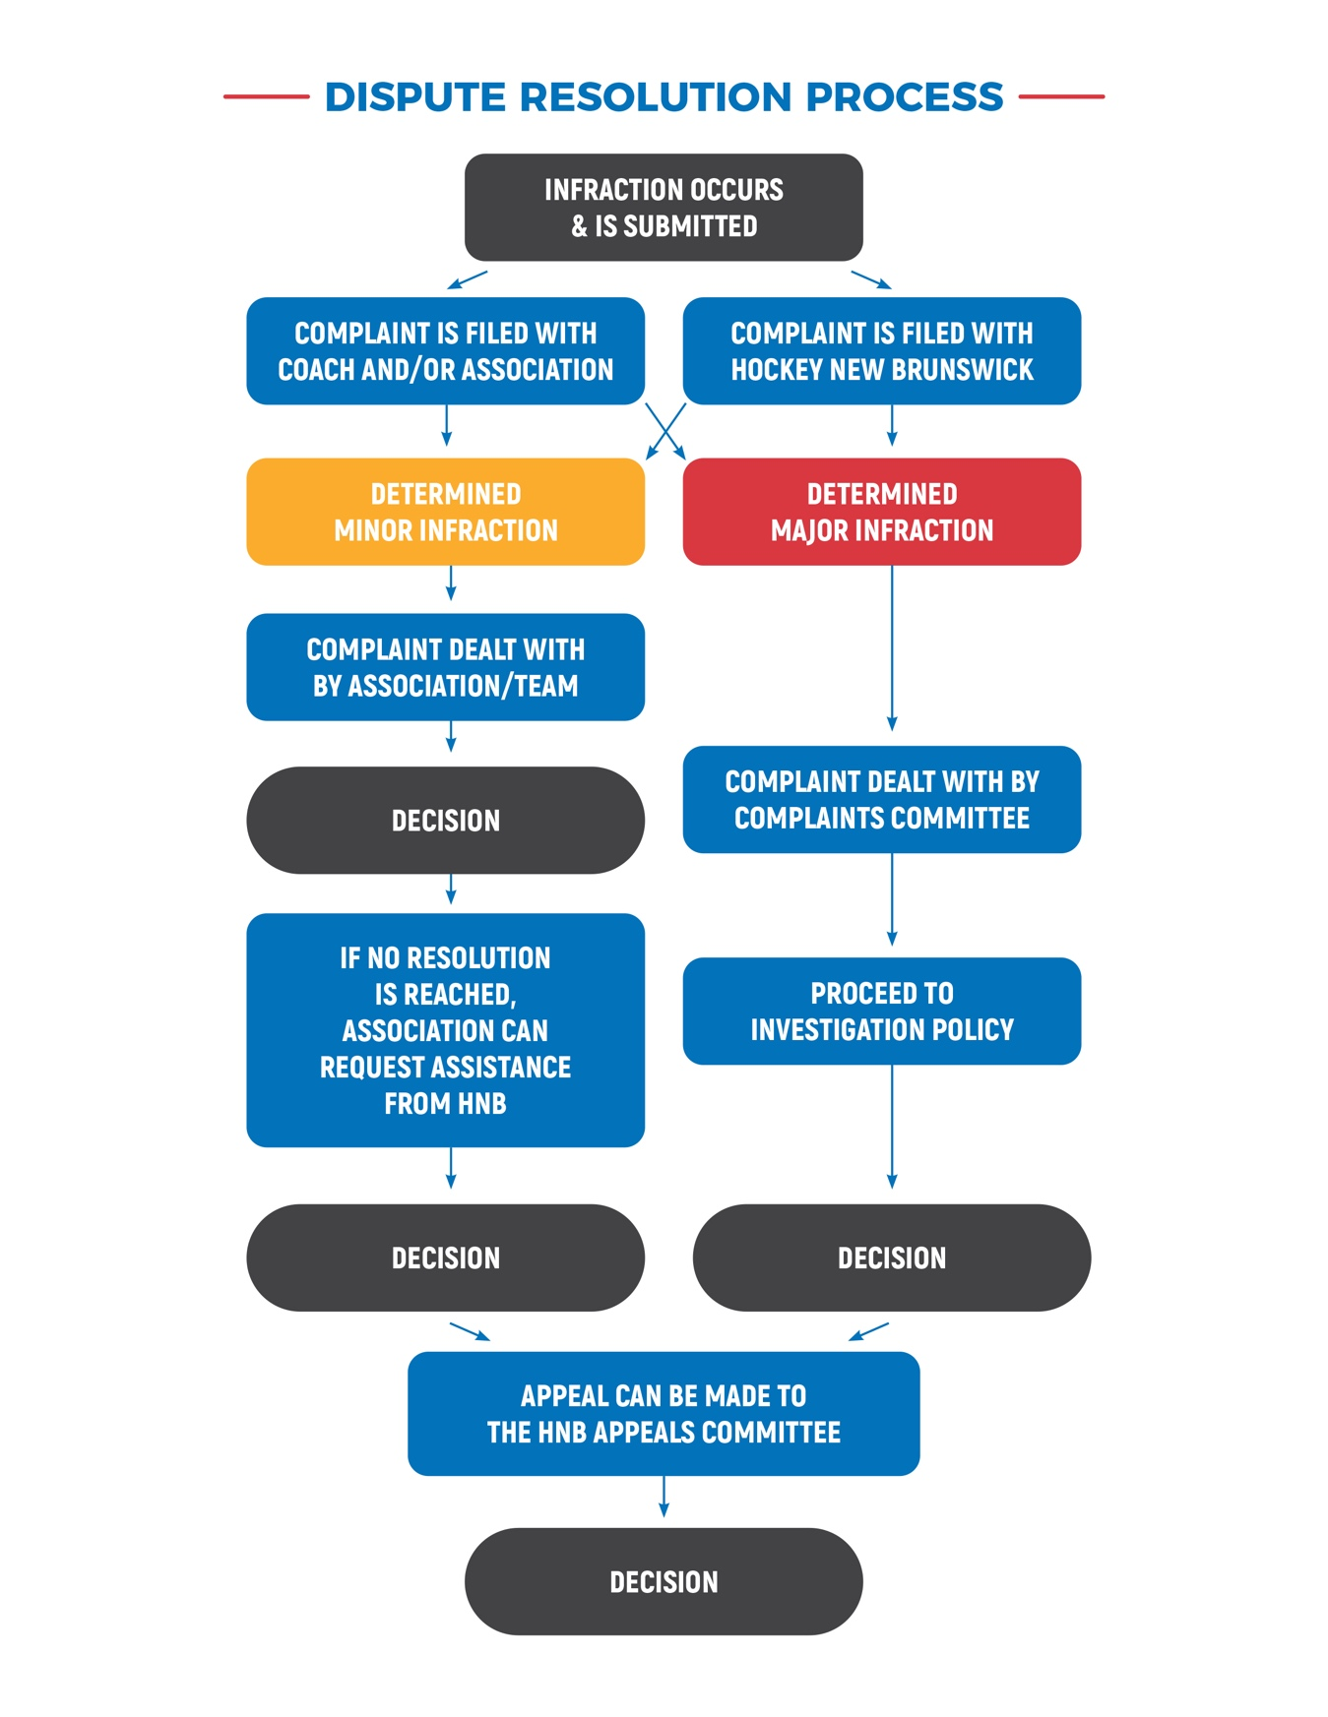

DECISION

