Complaint Intake Form
Please note the following:
- Complaints will be addressed in accordance with the Hockey New Brunswick Safe Sport Policy Manual along with supporting policies that may apply on a case-by-case basis.
- Hockey New Brunswick cannot guarantee confidentiality. The contents of this document may be shared in an effort to resolve this complaint.
- Complaints related to Maltreatment, will be sent to Hockey Canada Independent Third Party.
- Complaints which are criminal in nature, will be forwarded to the local police authority, and will not be investigated by Hockey New Brunswick.
- Once completed, this form can be emailed to info@hnb.ca

Please complete the following:
- Person filing complaint: ☐ Player ☐ Parent ☐ Volunteer ☐ Official ☐ Employee

First Name |  | Last Name
Minor Hockey Association | Team |  | Position with Team/Association
Telephone Number |  | Email

- Person on whose behalf the complaint is made: (if same as above, leave blank)

First Name | Last Name
Birth Date (dd/mm/yyyy)

- Name of person(s) who the complaint is being filed against:

First Name | Last Name
Minor Hockey Association | Team | Title/Role
First Name | Last Name
Minor Hockey Association | Team | Title/Role

- When did the incident(s) occur? (dd/mm/yyyy): ___________________________________

- Particulars: Please provide a summary of the incident(s) you are complaining about. Your summary must answer the following questions. If additional space is required, you can attach a document.

- Date that the incident(s) happened
- Where did the incident happen?
- Who was involved?
- What happened?
- How do the incidents relate to the ground(s) you selected?
- Remedy/Resolutions you are seeking

- Witnesses
Did anyone else witness the incident? If so, please provide their name and contact information.
Witness # 1
First Name | Last Name
Telephone Number | Email
Relationship with complainant

Witness # 2

First Name | Last Name
Telephone Number | Email
Relationship with complainant

Witness # 3

First Name | Last Name
Telephone Number | Email
Relationship with complainant

- Declaration

I hereby declare that the information provided in this Complaint Form is true and correct to the best of my knowledge. I understand that if I have knowingly provided false information, I may be subject to disciplinary action by Hockey New Brunswick.

Name:

Date:

Signature:

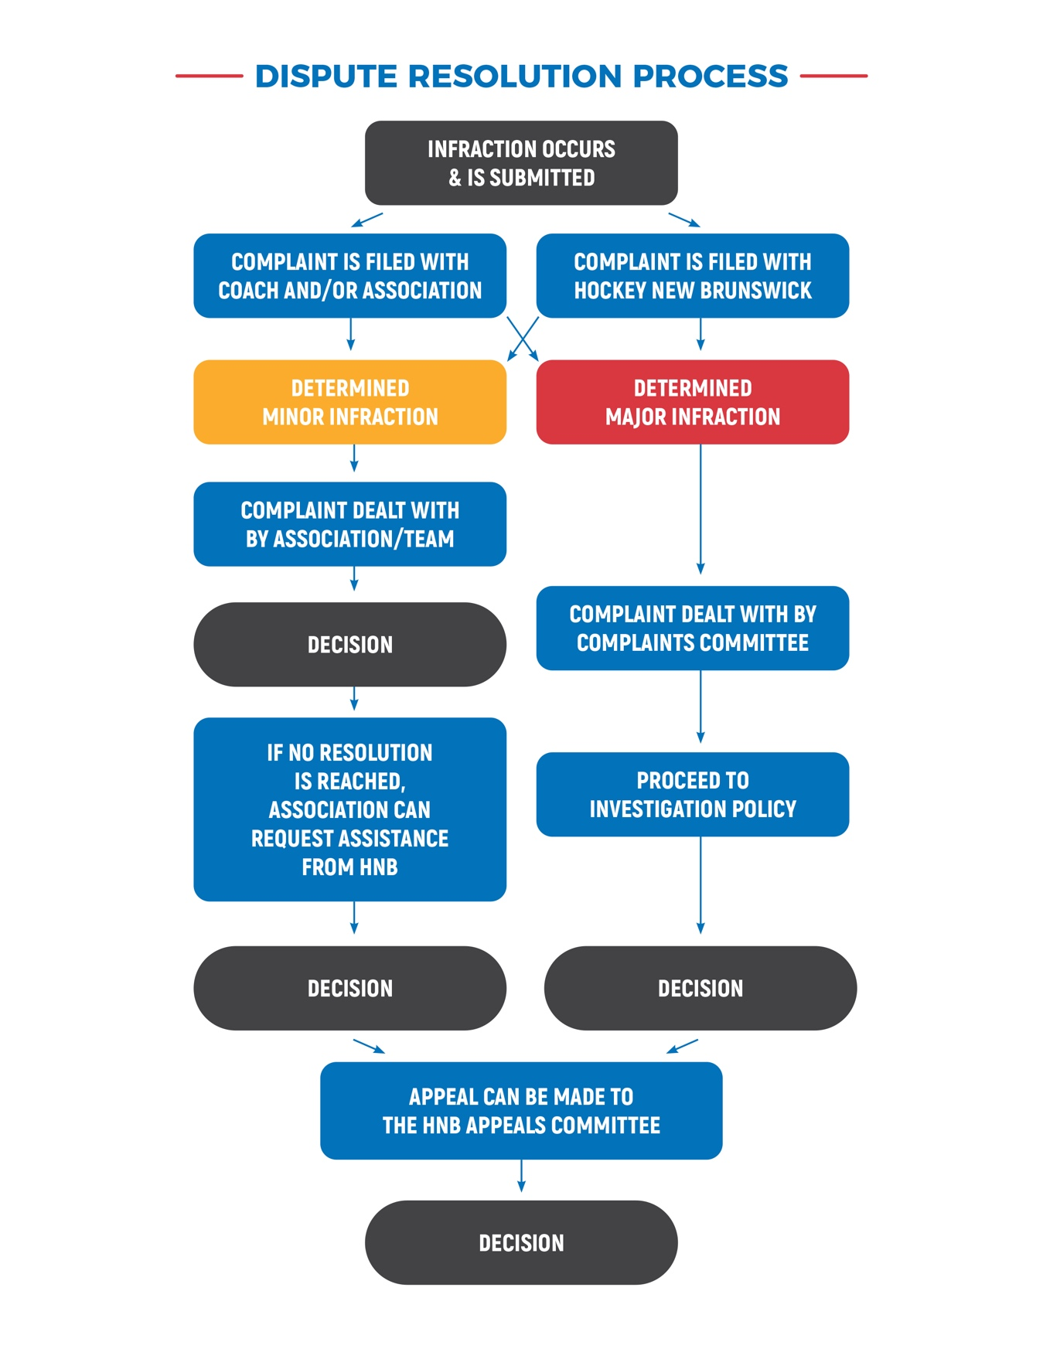

DECISION

