Complaint Intake Form
Please note the following:
- Complaints will be addressed in accordance with the Hockey New Brunswick Safe Sport Policy Manual along with supporting policies that may apply on a case-by-case basis.
- Definitions are provided in the Appendix of this document (Bullying, Harassment, Maltreatment, Misconduct, etc).
- Hockey New Brunswick cannot guarantee confidentiality. The contents of this document may be shared in an effort to resolve this complaint. The defendant will have the right to see the complaint, in order to defend the allegations.
- Complaints which are criminal in nature, will be forwarded to the local police authority, and will not be investigated by Hockey New Brunswick.
- Once completed, this form can be emailed to info@hnb.ca

Please complete the following:
- Person filing complaint: ☐ Player ☐ Parent ☐ Volunteer ☐ Official ☐ Employee

First Name |  | Last Name
Minor Hockey Association | Team |  | Position with Team/Association
Telephone Number |  | Email

- Person on whose behalf the complaint is made: (if same as above, leave blank)

First Name | Last Name
Birth Date (dd/mm/yyyy)

- Name of person(s) who the complaint is being filed against:

First Name | Last Name
Minor Hockey Association | Team | Title/Role
First Name | Last Name
Minor Hockey Association | Team | Title/Role

- When did the incident(s) occur? (dd/mm/yyyy): ___________________________________

- Please check the grounds that best describe your complaint:

- ☐Harassment (refer to Appendix)
Type of behaviour:
☐Conduct | ☐Gestures | ☐Comments
Based on:
☐Race | ☐Ethnicity | ☐Disability | ☐Colour
☐Religion | ☐Age | ☐Sexual Orientation | ☐Sex/Gender
☐Marital Status | ☐Family Status | ☐Abuse of Power
- ☐Maltreatment (refer to Appendix)
Type of behaviour:
☐Psychological | ☐Physical | ☐Neglect | ☐Sexual | ☐Aiding / Abetting
- ☐Bullying (refer to Appendix)

Type of behaviour:
☐Physical | ☐Verbal | ☐Social | ☐Cyber Bullying

- ☐Misconduct (refer to Appendix)

- Particulars: Please provide a summary of the incident(s) you are complaining about. Your summary must answer the following questions. If additional space is required, you can attach a document.

- Date that the incident(s) happened
- Where did the incident happen?
- Who was involved?
- What happened?
- How do the incidents relate to the ground(s) you selected?
- Remedy/Resolutions you are seeking

- Witnesses
Did anyone else witness the incident? If so, please provide their name and contact information.
Witness # 1
First Name | Last Name
Telephone Number | Email
Relationship with complainant

Witness # 2

First Name | Last Name
Telephone Number | Email
Relationship with complainant

Witness # 3

First Name | Last Name
Telephone Number | Email
Relationship with complainant

- Declaration

I hereby declare that the information provided in this Complaint Form is true and correct to the best of my knowledge. I understand that if I have knowingly provided false information, I may be subject to disciplinary action by Hockey New Brunswick.

Name:

Date:

Signature:

Appendix A: Definitions
- Maltreatment
i) Psychological Maltreatment occurs when any Participant, including a Participant in a position of power, repeatedly or severely attacks another Participant’s self-esteem through use of language, gestures or other behaviour that is degrading, isolating, humiliating, terrorizing, rejecting, or corrupting. This can be done in person or through technology. Psychological Maltreatment includes, without limitation:
- Verbal acts, such as verbally assaulting or attacking someone. Examples of prohibited verbal acts include: unwarranted personal criticisms; body shaming; derogatory and/or discriminatory comments related to one’s identity; comments that are demeaning, humiliating, belittling, intimidating, insulting or threatening; the use of rumours or false statements about someone to diminish the person’s reputation; and using confidential sport and non-sport information inappropriately.
- Non-assaultive physical acts, which are physically aggressive behaviours without physical contact. Example of prohibited non-assaultive physical acts include: throwing objects at or in the presence of others without striking another; and hitting, striking or punching objects in the presence of others.
- Acts that deny attention or support. These are acts of commission that deny attention, which include: ignoring psychological needs or socially isolating a person repeatedly or for an extended period of time; abandonment of a participant as punishment for poor performance; and arbitrarily or unreasonably denying feedback, training opportunities, support or attention for extended periods of time and/or asking others to do the same.
Psychological Maltreatment does not include any decision taken by Team Personnel not to select a Athlete for a particular Team, or any decision to limit Athlete’s ice time or role within a Team, so long as the decision was made in good faith, and does not include behaviour of the type described in i, ii, or iii.
ii) Physical Maltreatment occurs when any Participant, including a Participant in a position of power, physically hurts or by any means deliberately creates a significant risk of physical harm to another Participant. Physical Maltreatment includes, without limitation:
- Contact behaviours, such as: punching, kicking, beating, striking, strangling, slapping another, or deliberately striking another with objects.
- Non-contact behaviours, including: isolating a person in a confined space; forcing a person to assume a painful stance or position for no legitimate athletic purpose; the use of exercise for the purposes of punishment; withholding, recommending against, or denying adequate hydration, nutrition, medical attention or sleep; denying access to a toilet; providing alcohol to a Participant under the legal drinking age; providing illegal drugs or non-prescribed medications to a Participant; encouraging or knowingly permitting an Athlete to return to play prematurely following any injury or after a concussion and without the clearance of a medical professional; and encouraging an Athlete to perform a skill for which they are known to not be developmentally ready.
iii) Neglect Includes, without limitation: not providing an Athlete recovery time and/or treatment for a sport injury; not being aware of and not considering a Participant’s physical or intellectual disability; not considering supervision of an Athlete during travel, training or competition; failing to ensure safety of equipment or environment; allowing a Participant to disregard sport’s rules, regulations and standards; and subjecting Participants to the risk of Maltreatment.
iv) Sexual Maltreatment, which is a form of sexual violence, includes any act targeting a Participant’s sexuality, gender identity, or gender expression that is committed, threatened or attempted against a Participant, and includes but is not limited to the Criminal Code offences of sexual assault, sexual exploitation, sexual interference, invitation to sexual touching, indecent exposure, voyeurism, and non- consensual distribution of sexual/intimate images. Sexual Maltreatment also includes sexual harassment and stalking, cyber-harassment, cyber-stalking of a sexual nature, and engaging in Grooming.
v) Aiding and Abetting is any act taken with the purpose of facilitating, promoting or encouraging the commission of Maltreatment by another Participant. Aiding and Abetting includes, without limitation, knowingly:
- Allowing any Participant who has been suspended or is otherwise ineligible as a result of a violation of this Policy, to be in any way associated with sport ;
- Providing any coaching-related advice or service to a Participant who has been suspended or is otherwise ineligible; and
- Allowing any Participant to violate the terms of their suspension or any other sanctions imposed pursuant to this Policy.
Maltreatment (including Maltreatment of a Minor and Aiding and Abetting) in any form may lead to criminal liability under the Criminal Code, as well as to sanctions in accordance with this Policy.
- Bullying

Bullying is defined as the combined use of negative aggression and power. It occurs when one or more Participants direct verbal, physical or social aggression at another Participant. Harm inflicted by Bullying may be physical, psychological, social or educational. Bullying includes a continuum of hurtful behaviours that can range in severity from name-calling to criminal assault.

There are many forms of Bullying:

i) Physical Bullying includes inappropriate conduct directed towards a participant (e.g. hitting, kicking, shoving, spitting, beating up), or towards a participant’s property (e.g. stealing or damaging property).

ii) Verbal Bullying includes name-calling, mocking, hurtful teasing, humiliating or threatening participant.

iii) Social Bullying includes rolling your eyes or turning away from a participant, excluding participant from a group, gossiping or spreading rumours, setting other participants up to look foolish, or damaging friendships.

iv) Cyber Bullying includes the use of social media platforms, email, cell p hones, text messages and internet sites to threaten, harass, embarrass, humiliate, socially exclude or damage another participant’s reputation and relationships.

- Harassment
Harassment can occur in person, virtually, in writing, or through a third party. Harassment may occur between peers (e.g.: player to player of the same age group, parent to official, coach to coach) or between a Participant in a position of power or authority over another Participant (e.g.: coach to player, sports administrator to employee).
Harassment can be generally defined as engaging in a course of vexatious comments or behaviours against a person that is known or ought reasonably to be known to be unwelcome, and includes, without limitation, abuse of power, harassment based on protected grounds of discrimination under human rights legislation and sexual harassment. Harassing behaviour can involve comments, conduct or gestures which are insulting, intimidating, humiliating, hurtful, malicious, degrading or otherwise offensive. It may also include behaviour which creates an uncomfortable environment, or which might reasonably be expected to cause embarrassment, insecurity, discomfort, offense or humiliation to another Participant or group. Harassing behaviour includes, but is not limited to:
- Written or verbal abuse or threats;
- Unwelcome remarks, jokes, innuendos, or taunting about a Participant's body, sexual orientation, gender identity or expression, attire, age, marital status, ethnic or racial origin, religion;
- Displaying of racist or other offensive or derogatory material;
- Racial, ethnic or religious graffiti;
- Practical jokes which cause awkwardness or embarrassment, endangering a Participant’s safety or negatively affecting performance;
- Hazing or initiation rites;
- Obscene gestures;
- Intimidation;
- Behaviour which undermines self-respect or adversely affects performance or working conditions;
- False accusations of Harassment motivated by malice or mischief, and meant to cause harm to other Participants; and
- In certain circumstances, Harassment could be criminal in nature
ii) Abuse of Power
Abuse of power can constitute Harassment:
  - When submission to any conduct is made (either implicitly or explicitly) a condition of employment/volunteering/participating;
  - When rejection of such conduct is used as a basis for any decision; or
  - When such conduct has the purpose or the effect of interfering with a Participant’s
work/sport performance or creating an intimidating, offensive or hostile environment.
iii) Sexual Harassment
Sexual Harassment can be defined as engaging in a course of vexatious comment or conduct against a Participant because of sex, sexual orientation, gender identity or gender expression, where the course of comment or conduct is known or ought reasonably to be known to be unwelcome; or making a sexual solicitation or advance where the Participant making the solicitation or advance is in a position to confer, grant or deny a benefit or advancement to the recipient and the Participant knows or ought reasonably to know that the solicitation or advance is unwelcome. In sexual Harassment, power is derived from targeting another’s gender, sexuality, sexual orientation, or some other physical or psychological vulnerability related to sexuality. It can include but is not limited to:
  - Displaying of sexually offensive pictures, cartoons or other materials;
  - Persistent or unwelcome invitations or requests;
  - Unwelcome questions or sharing of information regarding a Participant’s sexuality, sexual activity or sexual orientation;
  - Conduct or comments intended to create, or having the effect of creating, an intimidating, hostile or offensive environment; or
  - Touching another Participant’s body without consent.
It is important to note that some of the behaviours listed above, when directed towards a Minor, may constitute abuse under child protection legislation. This may also be true of other behaviours, for example, certain hazing practices. In such cases, the duty to report which arises under the provisions of the applicable provincial or territorial legislation and under this Policy is applicable.
All forms of Harassment listed above may also constitute Maltreatment.
- Misconduct

Misconduct refers to any behaviour that is found to be in violation of the Hockey. New Brunswick Code of Conduct and that does not otherwise classify as harassment, maltreatment, or bullying.
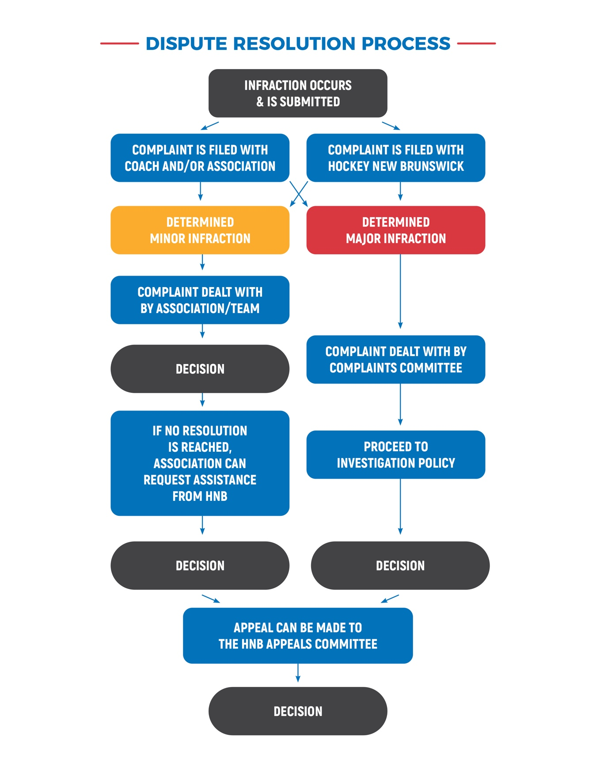
DECISION

